I233018
AbdulBasit
SE4B

task1:

#!/bin/bash

echo -e "My name is abdul basit.\nI am 20 years old and my favourite color is green."

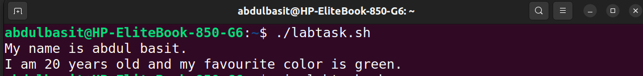

task2:
#!/bin/bash

num=5
if [ $num -lt 0 ]; then
echo "Negative number"
elif [ $num -gt 0 ]; then
echo "Positive number"
else
echo "Number is 0"
fi

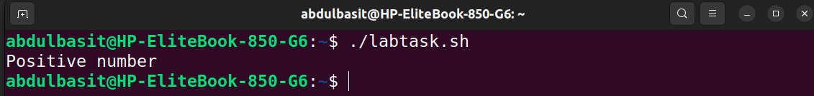
task3:
#!/bin/bash

num=5
if [ $num -lt 10 ]; then
echo "Small number"
elif [ $num -lt 20 ]; then
echo "Medium number"
else
echo "Large number"
fi
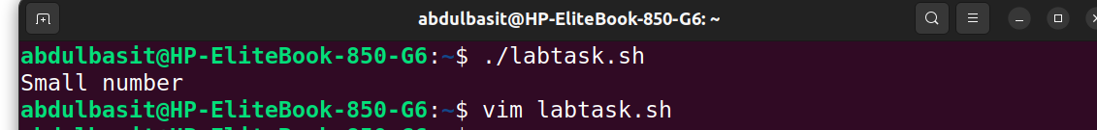

task4:
#!/bin/bash

for i in {1..5}
do
echo $i
done

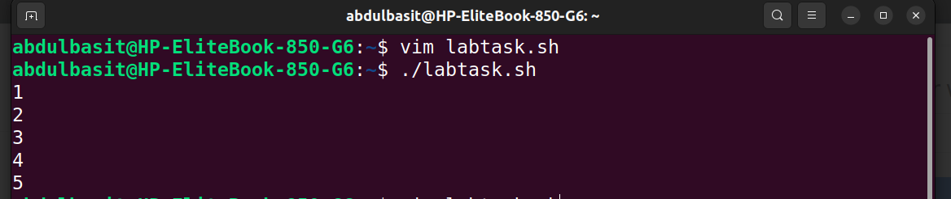
task5:
#!/bin/bash

num=1

while [ $num -lt 6 ]
do
echo $num
num=$((num+1))
done
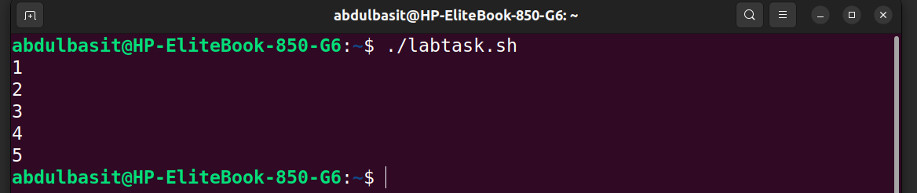
task6:
#!/bin/bash

num=1
num2=10

result=$((num+num2))

echo "Result of sum of $num and $num2 is $result"
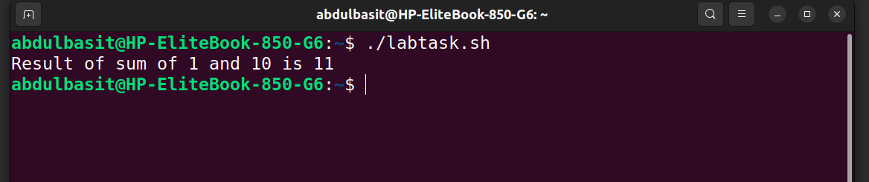
task7:
#!/bin/bash

str=""

if [ -z "$str"]; then
echo "String is empty"
else
echo "String is NOT empty"

fi
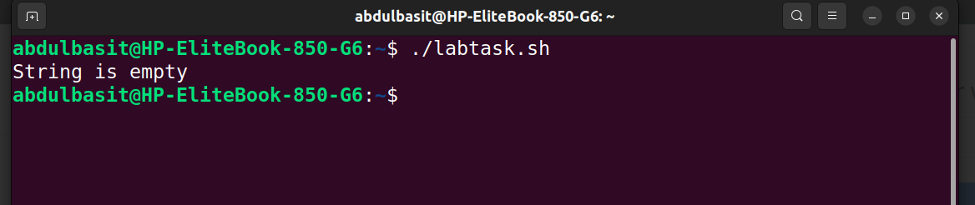
task8:
#!/bin/bash

file="/home/abdulbasit/i23_3018/i23_3018.txt"

if [ -f "$file" -a -r "$file" ]; then
echo File exists AND is readable
else
echo File does NOT exist AND is not Readable

fi
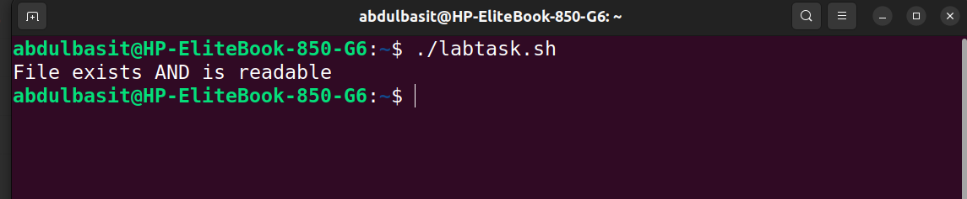
task9:
#!/bin/bash
file="/home/abdulbasit/oslab/lab3/tester.txt"

if [ -f "$file" -a -w "$file" ]; then
echo File exists and is Writable.
else
echo File does NOT exist and is NOT readable.
fi
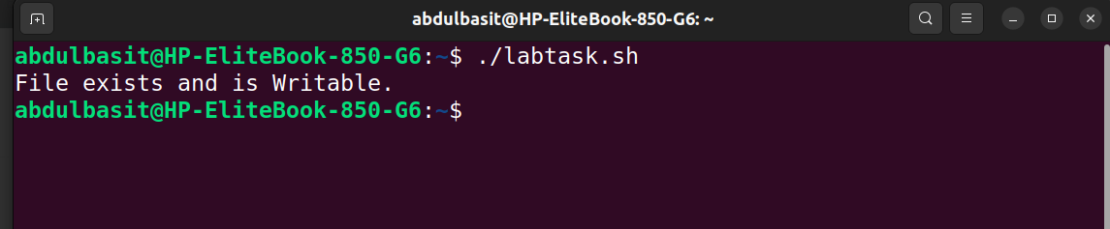
task10:
#!/bin/bash
dir="/home/abdulbasit/oslab/"

if [ ! -d "$dir" ]; then
echo Directory Does NOT exist.
else
echo Directory EXISTS.
fi

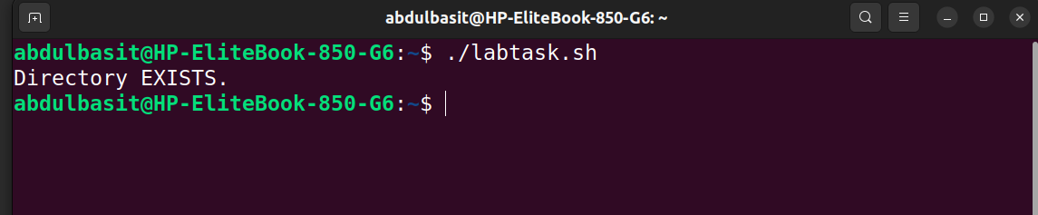

task11:
#!/bin/bash

num=-1

echo Enter your number :
read num

if [ $num -lt 0 ]; then
echo Number is negative.
elif [ $num -eq 0 ]; then
echo Number is ZERO.
elif [ $num -gt 0 -a $num -lt 10 ]; then
echo Small positive
else
echo Large Positive
fi
~

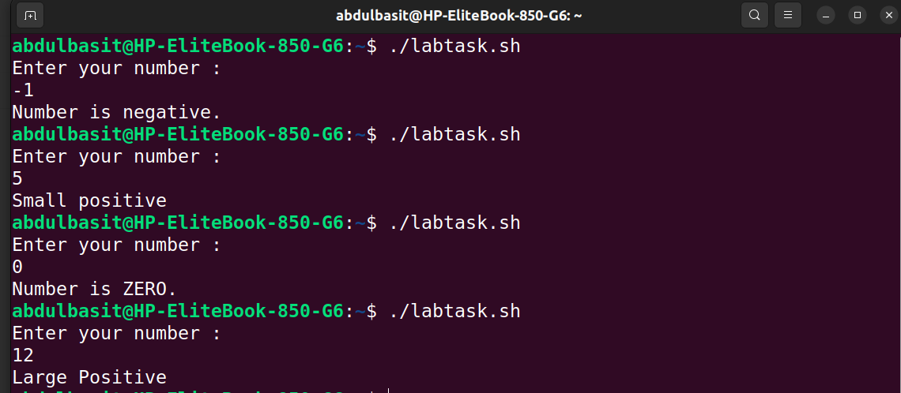
task12:
#!/bin/bash

file="/home/abdulbasit/oslab/lab3/tester.txt"

if [ -f "$file" -a -w "$file" -a -x "$file" ]; then
echo File exists AND is writable AND is Executable.
else
echo File is NOT writable AND Executable.
fi

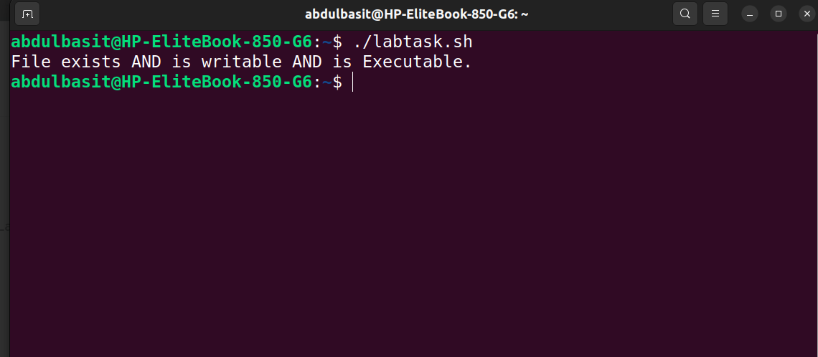
task13:
#!/bin/bash

file="/home/abdulbasit/oslab/lab3/tester.txt"

if [ -w "$file" -a -r "$file" ]; then
echo File is both Writable AND Readable
elif [ -r "$file" ]; then
echo File is only Readable
elif [ -w "$file" ]; then
echo File is only Writable
else
echo File Does NOT exist.
fi
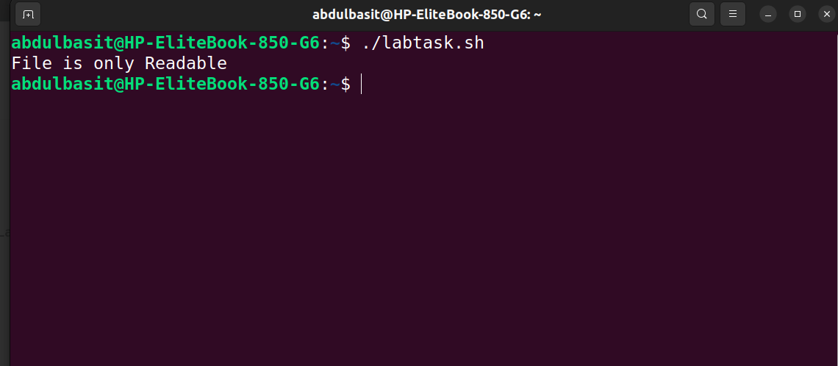
task14:
#!/bin/bash

for i in {1..10}
do
if [ $(( i%2 )) -eq 0 ]; then
echo $i is even.
else
echo $i is odd.
fi
done
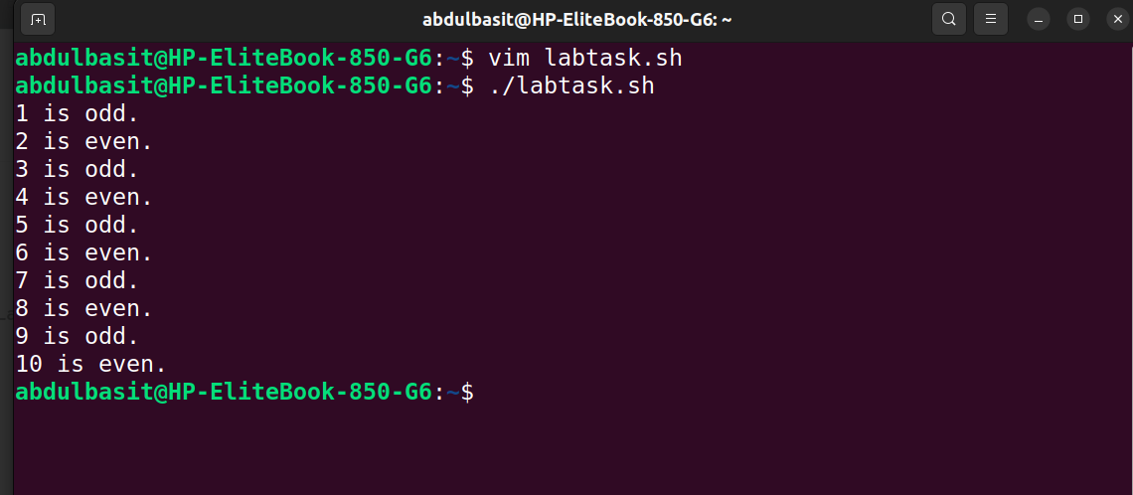
task15:
#!/bin/bash

num=1

while [ $num -lt 11 ]
do
if [ $num -eq 5 ]; then
break
else
echo $num
fi
num=$((num+1))

done

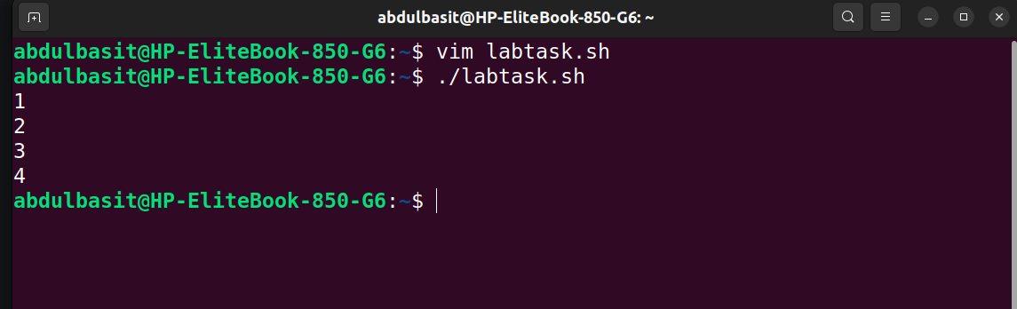

task16:

#!/bin/bash
dir="/home/abdulbasit/oslab"
file="/home/abdulbasit/oslab/lab3/tester.txt"
if [ -d "$dir" -a -w "$dir" -o -f "$file" -a -r "$file" ]; then
echo Dir exists and is Writable OR file exists and is Readable.
else
echo Condition was false
fi
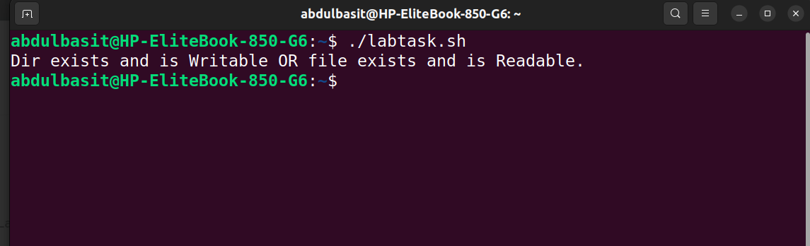
task17:
#!/bin/bash

for i in {1..10}
do
if [ $i -eq 7 ]; then
continue
else
echo $i
fi
done
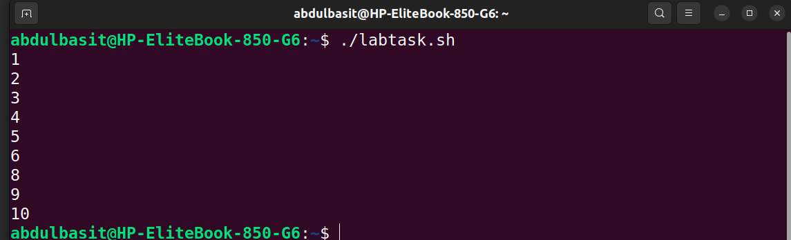
task18:

#!/bin/bash

num=0

while [ true ]
do
echo Running...
read num
if [ $num -eq 20 ]; then
break
fi
done

